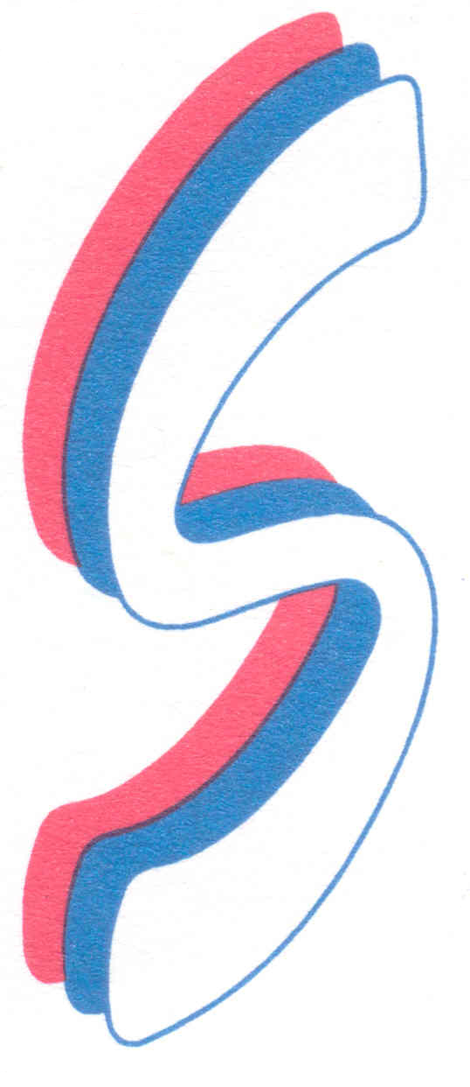
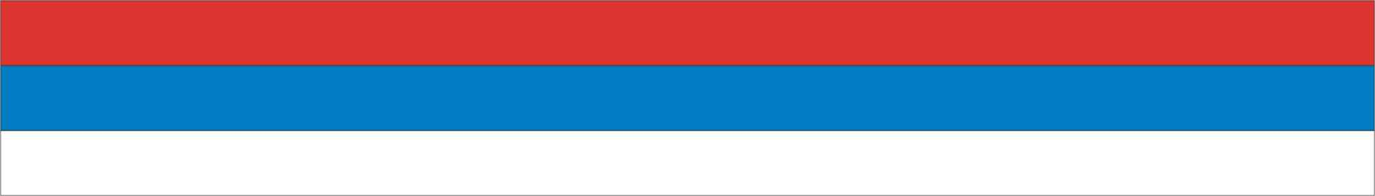

World sambo Championships 2007

18-22 October 2007 Sombor (Serbia)

RESULTS OF THE FIRST DAY OF COMPETITIONS

JOUTH MEN
48kg
1. MAMMADOV VUGAR AZE
2. KOPYLOV VALENTYN UKR
3. BOLDBAATAR DARKHANBOLD MNG
3. GORBULIN YAN RUS
5-6. MKHEIDZE VALERI GEO
5-6. MARGARYAN ARAMAYIS ARM
7. NACU ARNIOM MDA
8-9. KUSTSINSKI IHAR BEL
8-9. SUPYGALIYEV KAZABEK KAZ

60kg
1. NAVOSHA PAVEL BLR
2. PESKENTBAYEV SHOKAN KAZ
3. ABBASOV YASAR AZE
3. OVCHINNIKOV EVGENY RUS
5-6. IGITYAN KARAPET ARM
5-6. PASKAR ROMAN UKR
7. JESUS ALEXANDER VEN
9. OGLINDA VALERIU MDA
9. KISELIOV ILJA LTV
10-12. LEMIC NIKOLA SRB
10-12. BLAZEVICH RADMIR LVA
10-12. CHITASHVILI GEORGI GEO

75kg
1. GRIGORYEV ALEXANDER RUS
2. SATAYEV SAID KAZ
3. SHARLAI ARTUR UKR
3. GAVRGYAN GARIK ARM
5-6. GELACHVILI GIORGI GEO
5-6. PAVLOVAS ELVINAS LTV
7-8. EMANUILOV ILIYAN BGR
7-8. TELYMAN JAMSHIDBEK UZB
9-10. ROBINSON MANUEL VEN
9-10. CIRSTOIU GEORGHE MARIAN RUM
11-14. GINCU RADU MDA
11-14. HRYSHKEVICH VLADZIMIR BLR
11-14. SUZUKI TAISUKE JPN
11-14. STOJANOVIC LAZAR SRB

JOUTH WOMEN
40kg
1. ARACELYS GARCIA VEN
2. MATEVOSYAN MANIK ARM
3. SAVAITAN MARIA BLR
3. ANTONIC TANJA SRB
5. EDOMSKIKH YANA RUS

52kg
1. LUISAIGNA CAMPOS VEN
2. CHMYR TETYANA UKR
3. GRECU MONIKA ROM
3. IURCO TATIANA MDA
5-6. AISHUAKOVA AIGERIM KAZ
5-6. VALOVA ANASTASIA RUS
7-8. KAMAROUSKSYA SNIZHANA BLR
7-8. STEFANOVA KALINA BGR
9-10. MARTINJUK MARIJANA SRB
9-10. GUNEVICIUTE MEILE LTV

65kg
1. GRISAY EKATERINA RUS
2. IVANOVA VANYA BGR
3. RAMIREZ YURIANGEL VEN
3. RABEKA YULIYA BLR
5. KRUMGOLDE VERONIKA LVA
5. BADANOVA EKATERINA MDA
7-8. MILKOVIĆ MILANA SRB
7-8. YUSHCHENKO MARIYA UKR

Chieff referee: A. Shejko (Belarus )

World sambo Championships 2007

18-22 October 2007 Sombor (Serbia)

RESULTS OF THE FIRST DAY OF COMPETITIONS

JUNIOR (MEN)
48kg
1. ABDULLAYEV AFGAN AZE
2. OMARBEKOV BEKET KAZ
3. GEJADZE GIORGI GEO
3. BAGAUTDINOV ILNUR RUS
5. PAPIKYAN HMAYAK ARM
5. ZORIGT SUKHCHULUUN MNG

62kg
1. PULYEV MIKHAIL RUS
2. KAZARYAN TIGRAN UKR
3. BAKHTADZE GIORGI GEO
3. MANOLE VEACESLAN MDA
5-6. SATVALDIEV ILHOM UZB
5-6. NAGHDALYAN ANDRANIK ARM
7-8. HUBICH KIRIL BLR
7-8. MAILYBAYEV NURBOLAT KAZ
9-11. MENDES VIKTOR VEN
9-11. ENKHEE DELCERDORU MNG
9-11. LAZIC NENAD SRB

82kg
1. DUMINICA VALERIU MDA
2. HRYSHKEVICH RUSLAN BLR
3. PRIKAZCHIKOV VLADIMIR RUS
3. LUKINS MARTINS LVA
5-6. TKACHENKO ILLIA UKR
5-6. RAKISHEV BAUYRZHAN KAZ
7. REVILLA ROLAND VEN
8-9. KARBELASHVILI DAVIT GEO
8-9. MAJKIC PREDRAG SRB
10-12. AGHAMIROV MIRALAM AZE
10-12. SARGSYAN SARGIS ARM
10-12. THULLARD SELIM CHE
JUNIOR (WOMEN)
44kg
1. SHAYDUROVA OLESYA RUS
2. VASILEVA GLORIA BGR
3. BARRIOS JONALY VEN
3. BAIMURATOVA BIBIGUL KAZ
5. SAULITE VAIVA LTV

56kg
1. STANKAVISH ZHANNA RUS
2. BUCHKOVA IVA BGR
3. ZALETSKAYA HANNA BLR
3. LJIJANA OROZ BIH
5. DUARTE NARVELYS VEN

68kg
1. BARANOVA MARINA RUS
2. YURLEVICH DARYA BLR
3. GAINUTDINOVA LUIZA UKR
3. EVIA PUKITE LVA
5. MARKOVIC SANELA SRB
5. SADVAKASSOVA DIANA KAZ
7. HAYDAROVA GULASALHON UZB

Chieff referee: A. Shejko (Belarus )
Secretary General of the Championship: R. Zakirov (Russia)

