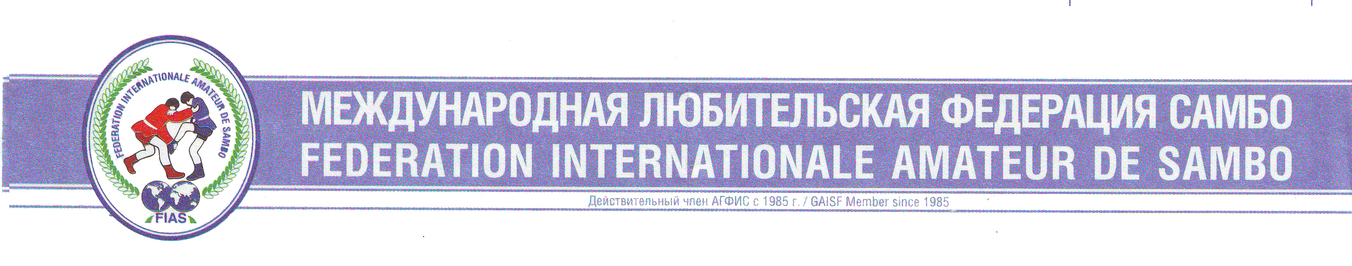

WORLD SAMBO CHAMPIONSHIPS 2007

LIST OF PARTICIPATING COUNTRIES

Первенство Мира по самбо среди юниоров и юниорок 1987-88г.р.,

юношей и девушек 1989-90 г.р.

18-22 оctober 2007 Sombor (Serbia)

 | Azerbaijan | AZE
 | Armenia | ARM
 | Belarus | BLR
 | Bulgaria | BGR
 | Venezuela | VEN
 | Georgia | GEO
 | Kazakhstan | KAZ
 | Latvia | LVA
 | Lithuania | LTV
 | Moldova | MDA
 | Russia | RUS
 | Serbia | SRB
 | Uzbekistan | UZB
 | Ukraine | UKR
 | Czechia | CZE
 | Japan | JPN
 | Romania | RUM
 | Mongolia | MNG
 | Tajikistan | TJK
 | Greece | GRE
 | Bosnia and Hercegovina | BIH
 | Montenegro | MNE
 | Switzerland | CHE

Chef referee _________________________ A.Shejko / Belarus/

Chef secretary _____________________ R.Zakirov / Russia/

