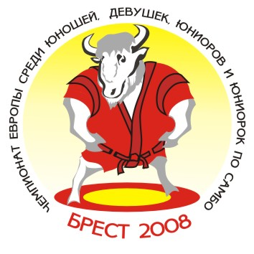 European Youth and Junior Sambo Championships 2008
Team’s results
Brest/ Republic of Belarus Men (17-18) May 16-18, 2008

№ п/п | Команды | ВЕСОВАЯ КАТЕГОРИЯ |  |  |  |  |  |  |  |  |  | Всего очков | Место
№ п/п | Команды | 48 | 52 | 56 | 60 | 65 | 70 | 75 | 81 | 87 | +87 | Всего очков | Место
1. | RUS | 3 | 7 | 5 | 7 |  | 1 | 5 | 5 | 5 | 3 | 41 | I
2. | BLR | 5 | 3 | 1 | 3 | 3 | 3 | 3 |  | 3 | 7 | 31 | 4
3. | UKR | 3 |  | 3 | 5 | 1 | 7 | 1 | 7 |  |  | 27 | 5
4. | GEO |  |  | 3 | 3 | 5 |  | 7 | 3 | 7 | 5 | 33 | II
5. | AZE | 7 | 5 | 7 | 1 |  | 5 | 3 |  | 3 |  | 31 | III
6. | ARM |  |  | 1 |  | 1 | 1 |  | 3 |  |  | 6 | 7
7. | BUL | 1 |  |  |  |  |  | 1 |  |  |  | 2 | 10-12
8. | LAT | 1 | 1 |  |  |  |  |  |  |  |  | 2 | 10-12
9. | MDA |  | 3 |  | 1 | 7 | 3 |  | 1 | 1 | 1 | 17 | 6
10. | LTU |  | 1 |  |  | 3 |  |  |  |  |  | 4 | 8
11. | FRA |  |  |  |  |  |  |  | 1 | 1 |  | 2 | 10-12
12. | SRB |  |  |  |  |  |  |  |  |  | 3 | 3 | 9

Главный судья_________________________(V.Bukhval) Главный секретарь ______________________(Y.Shoia)

