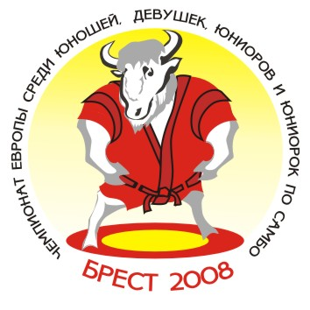 European Youth and Junior Sambo Championships 2008
Team’s results

Brest/ Republic of Belarus Men (19-20) May 16-18, 2008

№ п/п | Команды | ВЕСОВАЯ КАТЕГОРИЯ |  |  |  |  |  |  |  |  |  | Всего очков | Место
№ п/п | Команды | 48 | 52 | 57 | 62 | 68 | 74 | 82 | 90 | 100 | +100 | Всего очков | Место
1. | RUS | 5 | 7 | 7 | 7 |  |  |  | 7 | 5 | 7 | 45 | I
2. | BLR | 1 |  | 3 | 3 | 5 | 7 | 3 | 3 | 3 |  | 28 | III
3. | UKR | 3 | 3 |  | 1 |  | 3 |  |  | 1 |  | 11 | 7
4. | GEO | 7 | 3 | 1 | 5 | 1 | 5 | 7 | 3 | 3 | 3 | 38 | II
5. | AZE | 1 | 5 | 3 | 3 | 7 |  | 5 |  |  |  | 24 | 4
6. | ARM | 3 |  | 1 | 1 | 1 |  |  | 1 | 1 |  | 8 | 9
7. | MDA |  | 1 |  |  | 3 | 1 | 3 | 5 |  |  | 13 | 5
8. | LAT |  |  |  |  |  | 1 | 1 | 1 | 7 | 1 | 11 | 6
9. | GER |  |  |  |  |  |  | 1 |  |  |  | 1 | 13-14
10. | LTU |  | 1 |  |  |  |  |  |  |  | 5 | 6 | 10
11. | GRE |  |  |  |  | 3 |  |  |  |  |  | 3 | 11-12
12. | EST |  |  |  |  |  |  |  |  |  | 3 | 3 | 11-12
13. | SRB |  |  |  |  |  |  |  |  |  | 1 | 1 | 13-14
14. | BUL |  |  | 5 |  |  | 3 |  |  |  |  | 8 | 8

Главный судья_________________________(V.Bukhval) Главный секретарь ______________________(Y.Shoia)

