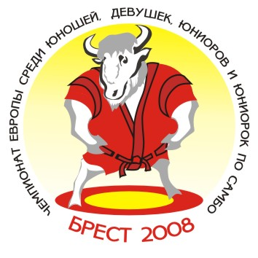
European Youth and Junior Sambo Championships 2008
Team’s results
Brest/ Republic of Belarus Women (19-20) May 16-18, 2008

№ п/п | Команды | ВЕСОВАЯ КАТЕГОРИЯ |  |  |  |  |  |  |  |  |  | Всего очков | Место
№ п/п | Команды | 44 | 48 | 52 | 56 | 60 | 64 | 68 | 72 | 80 | +80 | Всего очков | Место
1. | RUS | 3 | 5 | 5 | 5 | 7 | 3 | 3 | 5 | 3 | 7 | 46 | I-II
2. | BLR | 5 | 7 | 3 | 3 | 3 | 5 | 5 | 7 | 5 | 3 | 46 | I-II
3. | UKR | 3 | 3 | 1 | 3 | 5 | 7 | 3 | 1 | 3 | 5 | 34 | III
4. | ARM | 7 |  |  |  |  |  |  |  |  |  | 7 | 8
5. | BUL |  |  |  | 7 |  |  |  |  | 7 |  | 14 | 4
6. | LAT |  |  |  |  |  | 3 | 7 |  |  | 3 | 13 | 5
7. | LTU |  | 3 | 7 |  |  | 1 |  | 1 |  |  | 12 | 6
8. | MDA |  |  | 3 |  | 3 |  |  | 3 |  |  | 9 | 7
9. | CZE |  |  |  |  | 1 |  |  |  |  |  | 1 | 10
10. | SRB |  |  | 1 |  |  |  |  | 3 | 1 |  | 5 | 9

Главный судья_________________________(V.Bukhval) Главный секретарь ______________________(Y.Shoia)

