
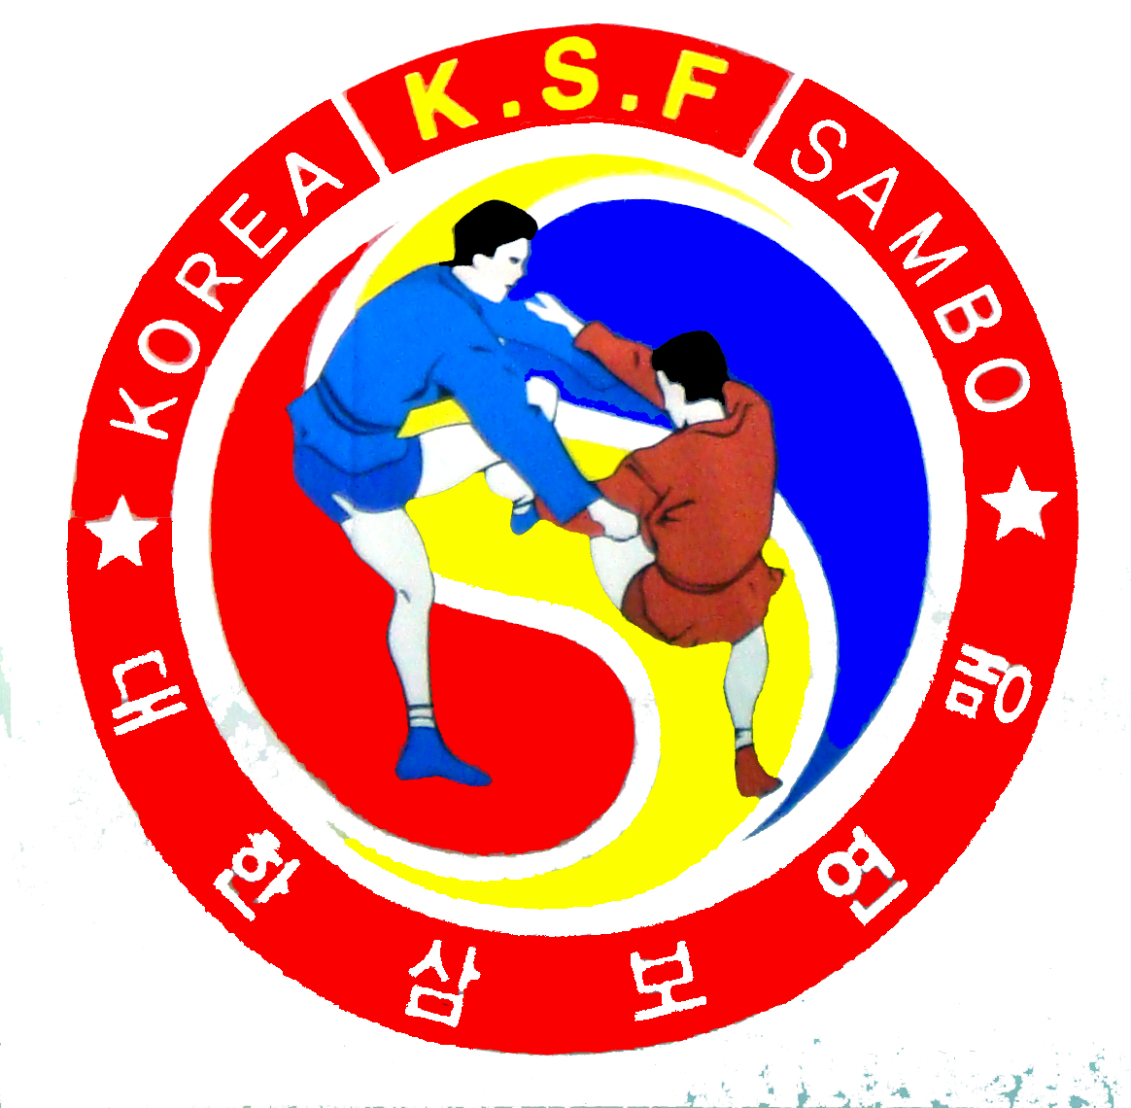
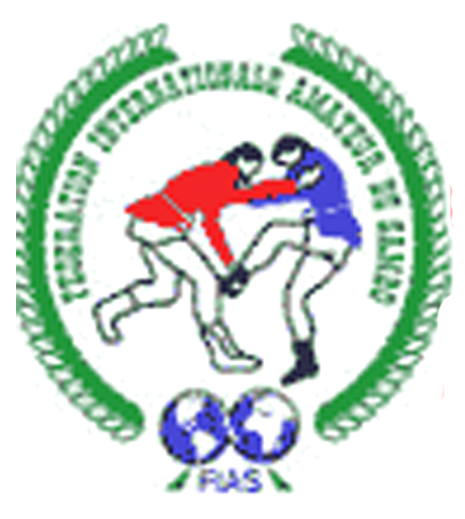

WINNERS AND PRIZE-WINNERS

2008 Busan TAFISA World Sport For All Game THE SAMBO WORLD GAME
25 September - 2 October 2008 Busan /R.Korea/
man |  | 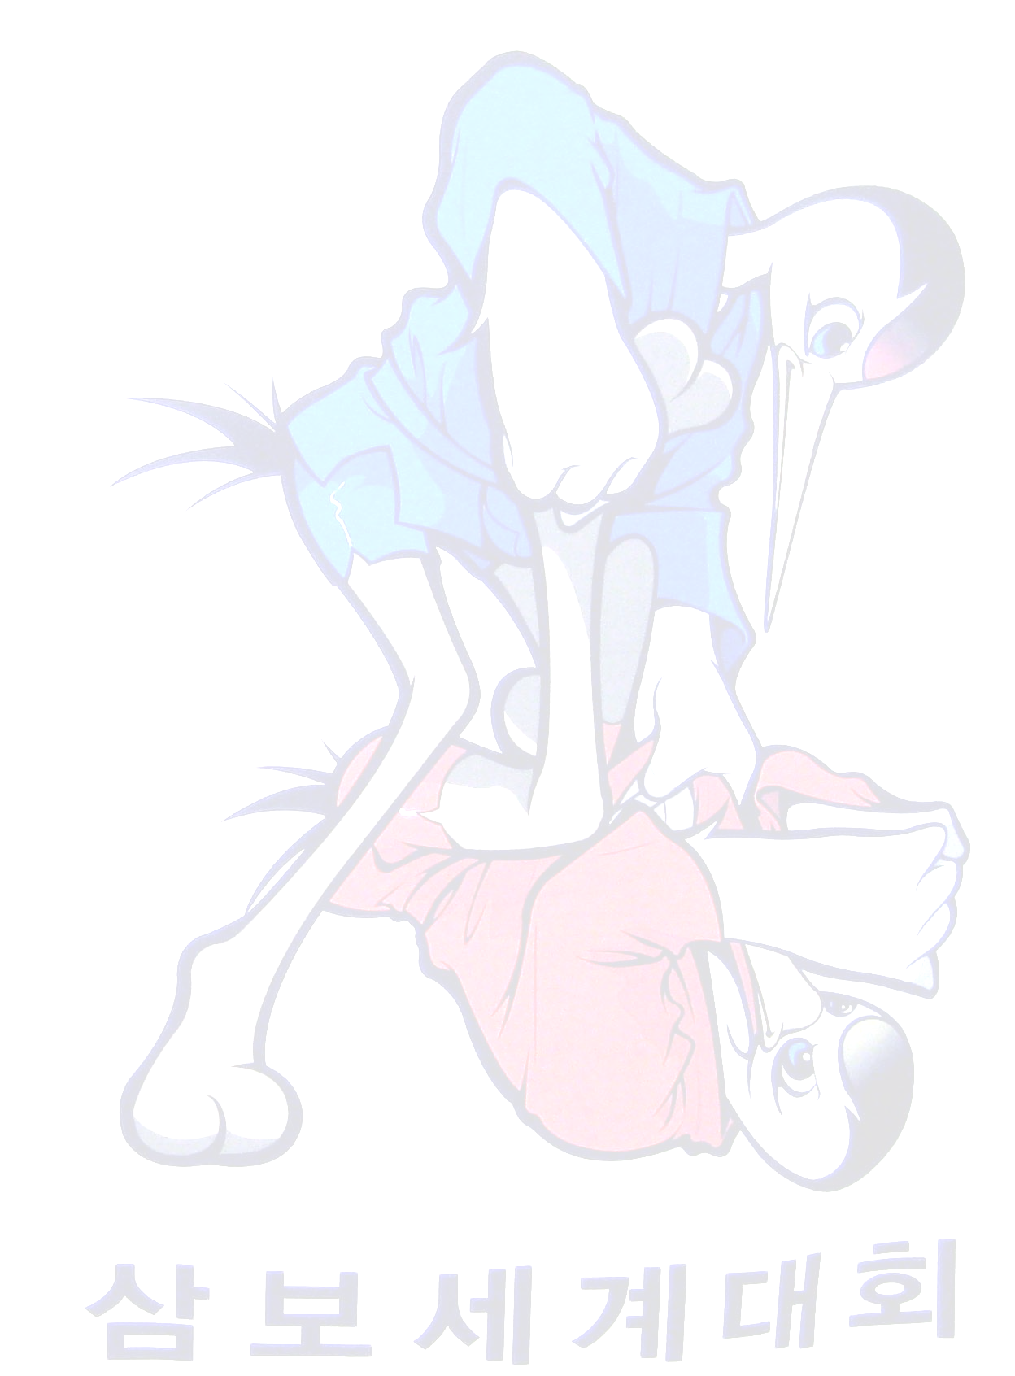 |  |  | woman
Taken place | Name | Yob. | Country/Team |  | Taken place | Name | Yob. | Country/Team
1 | HLIBOV Ilya | 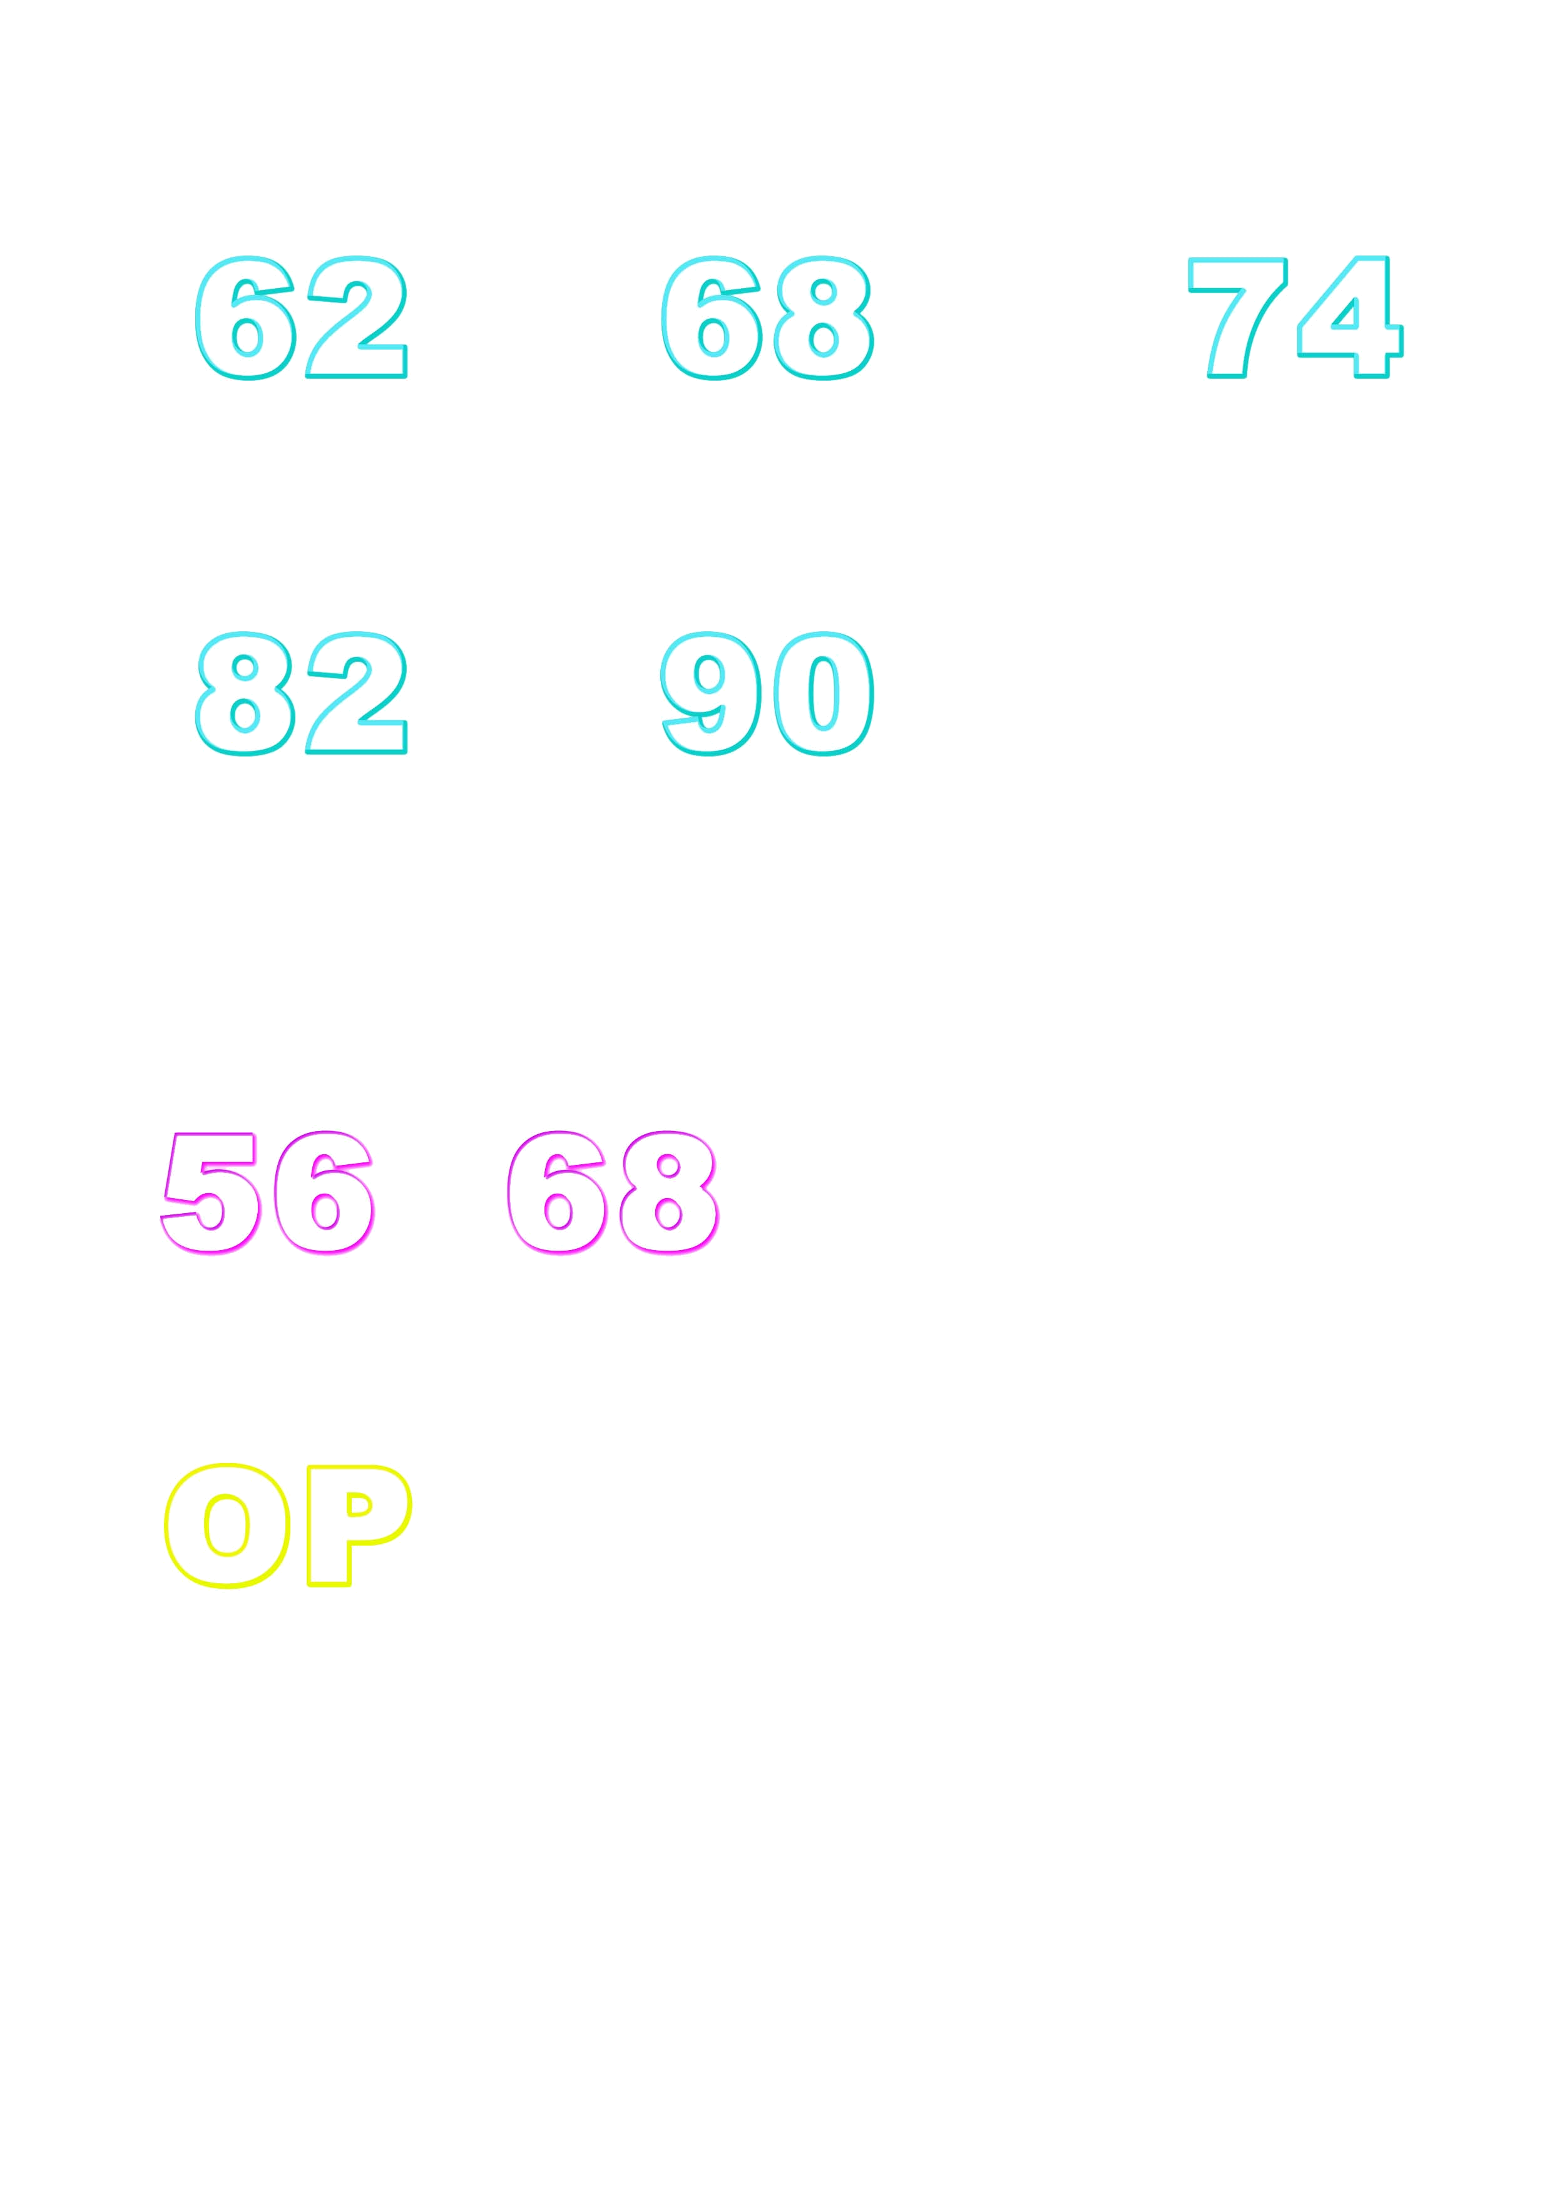  1986 | RUS |  | 1 | KORNEEVA Marina | 1982 | RUS
2 | BORREGALES Lucos | 1980 | VEN |  | 2 | RAZHEVA Elitsa | 1980 | BUL
3 | MUKANOV Azamat | 1987 | KAZ |  | 3 | MUNKHBAATAR Bundmaa | 1985 | MGL
3 | MARUDAV Aleksandr | 1980 | BLR |  | 3 | BAILIYEVA Raissa | 1975 | KAZ
1 | SANJAASUREN Miyaragchaa | 1983 | MGL |  | 1 | USOLTSEVA Оlga | 1984 | RUS
2 | KLETSKOV Nikita | 1986 | RUS |  | 2 | PUKITE Evija | 1988 | LAT
3 | GRECHICHO Sergej | 1985 | LIT |  | 3 | CHERAR Adriana | 1985 | KAZ
3 | MULLOEV Abulfayz | 1981 | TJK |  | 3 | KLIMASAUSKE Leva | 1972 | LIT
 |  |  |  |  | combat
1 | SHAROV Alexander | 1979 | RUS |  | Taken place | Name | Yob., Rank | Country/Team
2 | MAZIMBAYEV Maxat | 1985 | KAZ
 |  |  |  |  | 1 | SHUSHKO Stanislav | 1986 | RUS
3 | DANIELYAN Ashоt | 1984 | ARM
 |  |  |  |  | 2 | YESSIMKHANOV Dauren | 1982 | KAZ
3 | KOTANIDIS Aris | 1976 | GRE
 |  |  |  |  | 3 | CERNAVSKIS Vladislavs | 1977 | LAT
1 | RAKHMATULLIN Rais | 1975 | RUS |  | 3 | BOZHINOV Veselin | 1975 | BUL
2 | AKTAYEV Ruslan | 1983 | KAZ
3 | ISPIRYAN Armen | 1985 | ARM |  | 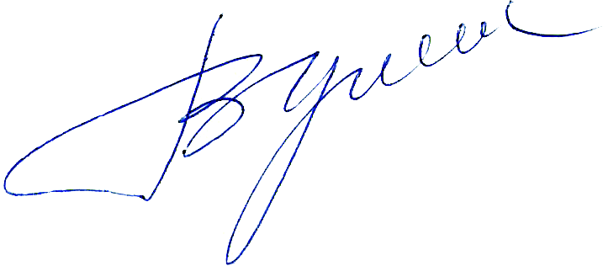
3 | LUKINS Martins | 1988 | LAT |  | Chiaf refery | 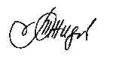 | V. Perchik | /RUS/
1 | CHERNOSKULOV Alsim | 1983 | RUS
2 | SIOMOCHKIN Evhenie | 1981 | BLR |  | Chiaf secretary |  | М.Jideliov | /MDA/
3 | LAMBERTO Kaffi | 1975 | ITA
3 | SULINS Jurijs | 1983 | LAT

