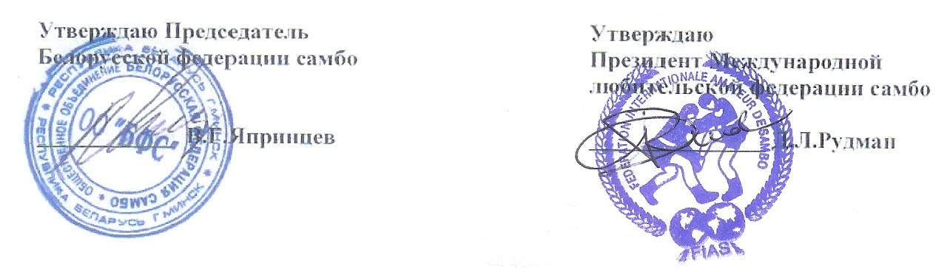
REGULATIONS
WORLD SAMBO CHAMPIONSHIP
AMONG VETERANS
16-19 October, 2008, Minsk, Belarus

- General conditions
1.1 Championships are held according to the Rules of Sambo currently in force and Regulations of FIAS.
1.2 Championships are organized and held by International Federation of Amateur Sambo-Wrestling (FIAS) and Belarus Sambo Federation.
1.3 Championships are held to popularize and develop sambo-wrestling and to consolidate the International sports contacts.

- Date and Place
2.1 Competitions will take place from 16 to 19 October, 2008 in the city of Minsk, Belarus.
2.2 Competition will be held in sport complex “Logoysk” (located 35 km from Minsk)
2.3 Accreditation will be held on October 16, 2008 from 11am to 6pm in the lobby of the sport complex hotel.

3. Participation terms.
The applications for participation should be sent to the Championship Organizing Committee till latest September 20th, 2008!
Each application must have the information about all the participants.
- surname and name as it is written in the foreign passport
- date of birth and number of the foreign passport

Belarus Sambo Federation is responsible for providing visa support only to the delegations with the information about the participant given on due time.

- Technical terms of Championships:
4.1 Sambo World Championship among veterans:
Age groups:
35-39 years, 40-44 years, 45-49 years, 50-54 years,55-59 years, 60-64 years 65 and older.
Weight categories among veterans:
62 kg, 68 kg, 74 kg, 82 kg, 90 kg, 100 kg, +100 kg

4.2 Competitions are held according to the FIAS Rules
4.3 Each sportsman must have medical examination before leaving the home country for the competitions. The results have to be marked in the fighter’s license.
4.4 The Organizing Committee guarantees first aid to all members of sport delegations.
4.5 Team places are given according to the points collected in the individual classification.
4.6 All participants, coaches, referees, and representatives must have medical insurance.
4.7 The international category referees are allowed to umpire according to the FIAS official invitation.
4.8 All delegations should have a cassette/CD with the National anthem and 2 National flags 1x2m.

5. Financial terms and accommodations.
5.1 Each member of the delegations must pay to the Organizing Committee participation fee counting US $75 per person per day (2 meals a day plus accommodation), US $15 fee for the transfer airport-hotel-place of the competition- and back.
Managers of sport delegations have to fulfill all financial obligations with Organizing Committee on the arriving day and carry out all accreditation demands.
5.2 Participants are allowed to compete only with FIAS license book with 2008 annual fee payment note.
(license book costs US $10; license – US $25)
5.3 Participants, arranging their own accommodation, must pay to the Organizing Committee one time fee of US $100.

ATTENTION!
Participants not included into the application form till the 20th of September but arriving to the competitions have to pay US $100 per day.

6. Rewarding of winners.
Sportsmen won first three prize places will be rewarded with medals, diploma and valuable prizes.

- Official Ceremonies.
7.1 Participants will take part in the official ceremonies of World Championship.
7.2 National anthems and rising of National flags ceremonies are performed in the honor of the winners.

P R O G R A M

October 16
Arrival of delegations
Check in and accreditation

14:00-16:00 Referees seminar
16:00-18:00 Medical control, Veterans weighting according age categories:
35-39 years
40-44 years
45-49 years
50-54 years

October 17
9:00-14:00 Preliminary matches among veterans age groups
35-39 years,
40-44 years,
45-49 years
50-54 years
14:00-15:30 Break
15:30 Grand Opening of the World Sambo Championship
16:00-18:00 Semi-Finals and Finals
18:00-19:00 Awards Ceremony
19:00-20:00 Veterans weighting according to age categories:
55-59 years,
60-64 years
65 and older

October 18
11:00-15:00 Preliminary matches among veterans age groups
55-59 years,
60-64 years,
65 and older
17:00-19:00 Semi-Finals and Finals
19:00-20:00 Awards Ceremony
20:00-20:30 Closing of the World Sambo Championship
21:00 Dinner

October 19
Day for rest and excursions

October 20
Departure of the delegations

Organizing Committee of World Sambo Championship among Veterans:
Belarus Sambo Federation
Prospect Nezavisimosty 32-b
Minsk, Belarus
Tel/Fax: + 375 17 328 64 68
Email: Tuflya@inbox.ru
versambo@list.ru

