Sport complex “SALA POLIVALENTA”



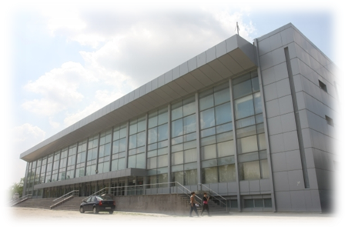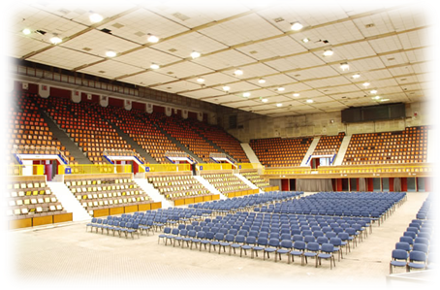

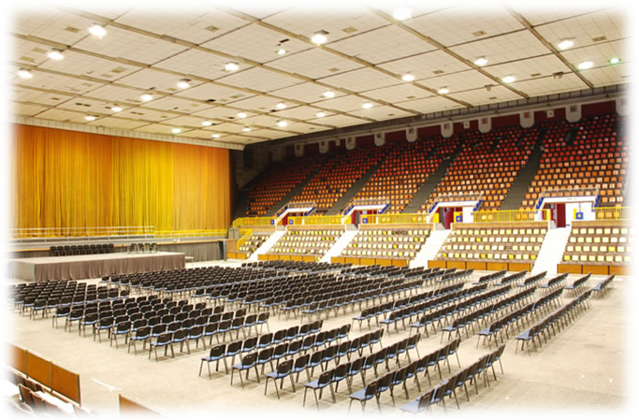
“Sala Polivalenta”, 10, Calea Piscului, District 4, RO 040404, Bucharest, Romania, www.salapolivalenta.ro

